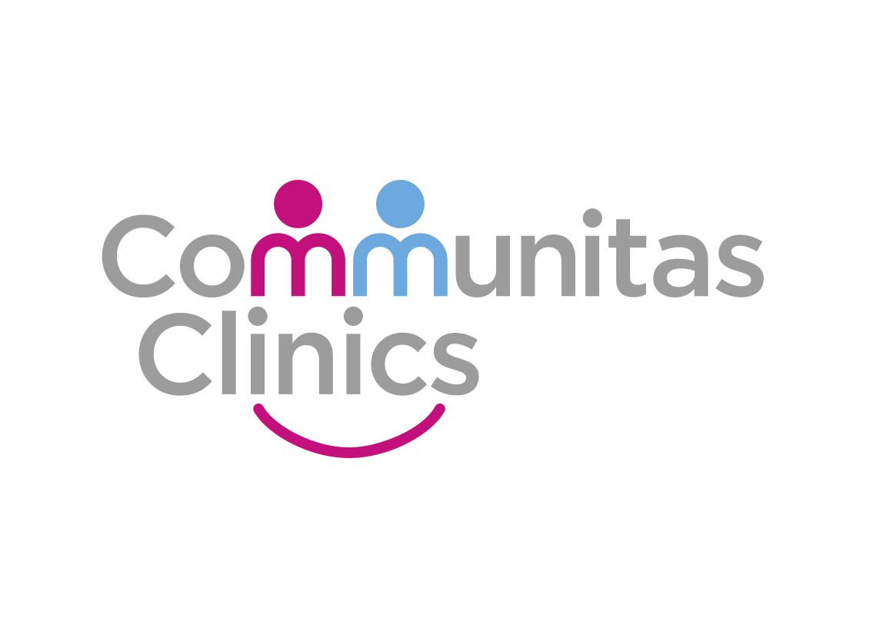

IT_SOP_32

Procedure Name: Review results through pathlink inbox

Version 1.0

Date: 21/10/2022

Document Revision History.

Date | Version | Authors | Comments/Reasons For Change
21/10/2022 | 1.0 | PH | First issue

Contents

Introduction. 4
Scope. 4
Update Policy. 4
Opening the inbox 4
Opening the reports 5
Filing the report 6

Introduction.
This document provides details of how to Review results through pathlink inbox

Scope.
This document defines how Communitas Clinics staff or clinicians can user the pathlink inbox, within SystmOne, to review pathology reports and results.

Update Policy.
The authorised document editors will review this policy annually and submit revisions to the Document owner for approval.
The authorised document editors will maintain and monitor, as required, data regarding the suitability of this procedure and amend, as necessary.

Opening the inbox

To access your Pathlink inbox, ensure you are on the homepage

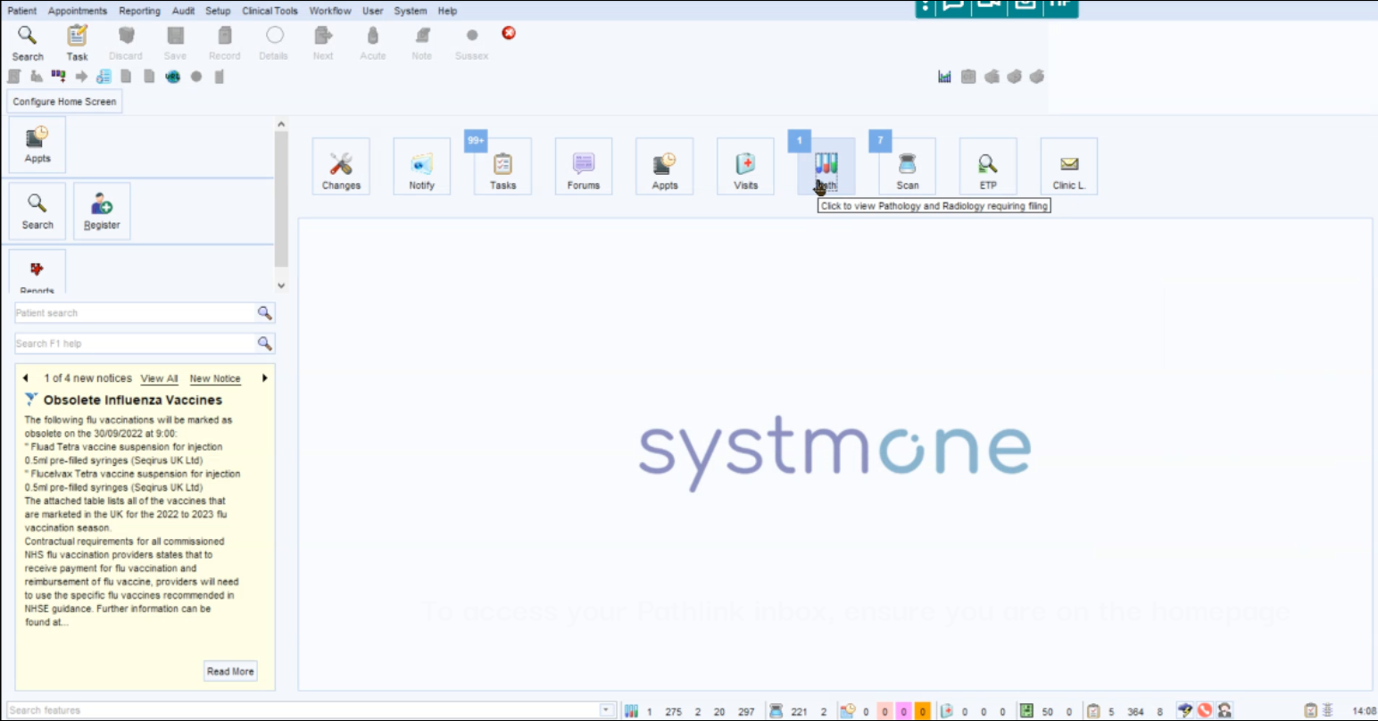

Select Icon called Path, then select pathology/radiology Inbox:

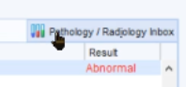

Or press Ctrl + Y

Opening the reports

Click on the tab at the top which is marked Reports Ready to File. Ensure the box Only show reports assigned or directed to me is ticked.

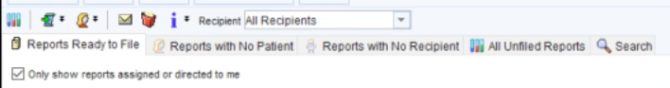

Right click on result and view report

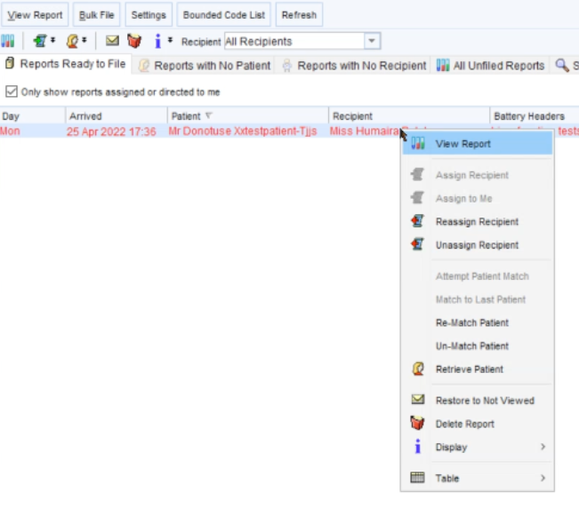

Review report (including all tabs as you will not be able to file this away until this has been done!)

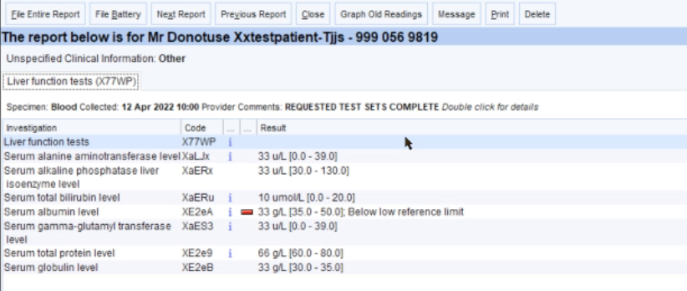

Filing the report

Click on File Entire Report (top left of the screen)

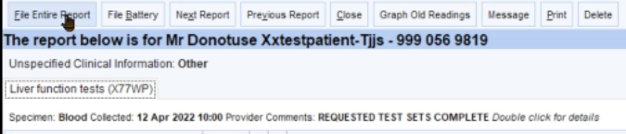

If the result matches the listed request, select the correct request and press OK. Otherwise click Do Not Link

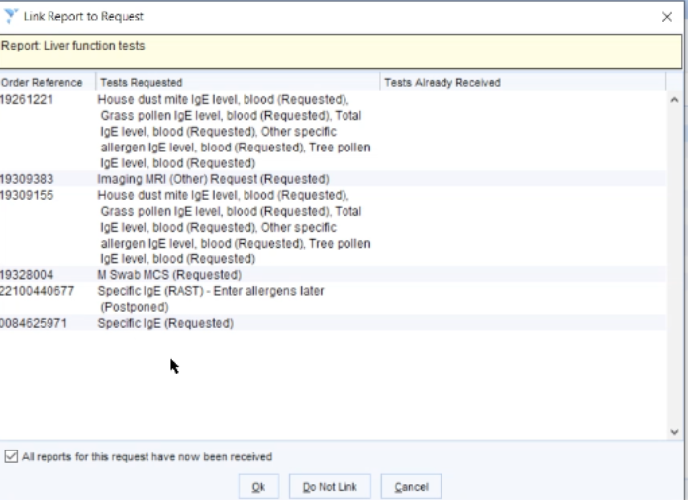

A result indicator window will load:
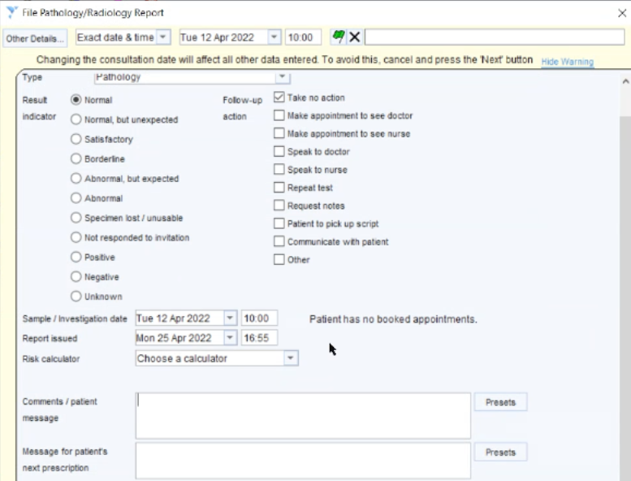

Select the appropriate outcome under ‘Result Indicator’ e.g. normal.

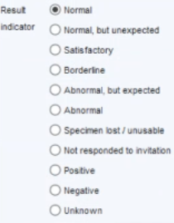

Select the appropriate outcome under ‘Follow-up action’. If you have selected ‘Other’, you must ensure you have stated what action is required. i. Follow up required in____ ii. Discharge from service iii. Refer to secondary care

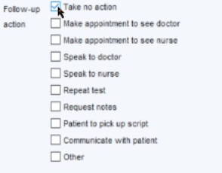

Select Archive and Create a Task.

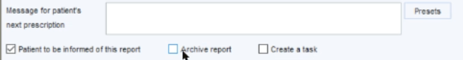

The task screen will be loaded – Select User Group: either Croydon ENT, BHR, Greenwich/ Bexley, Herts, City and Hackney

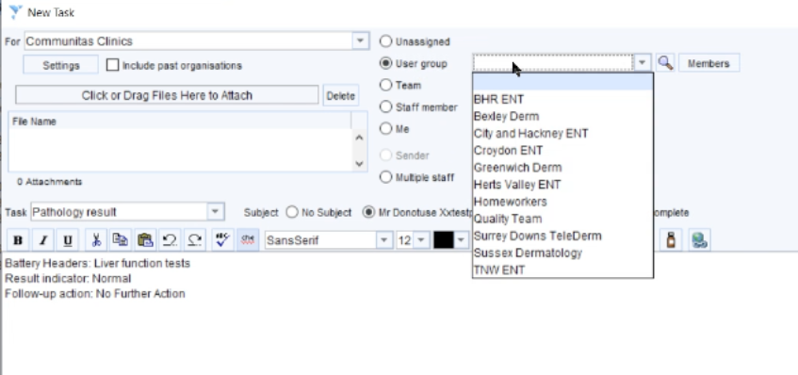

Check the task instruction is correct and add any additional comments.

Select a purple flag for routine results and select the red flag if the result is urgent

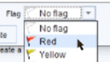

Click OK
