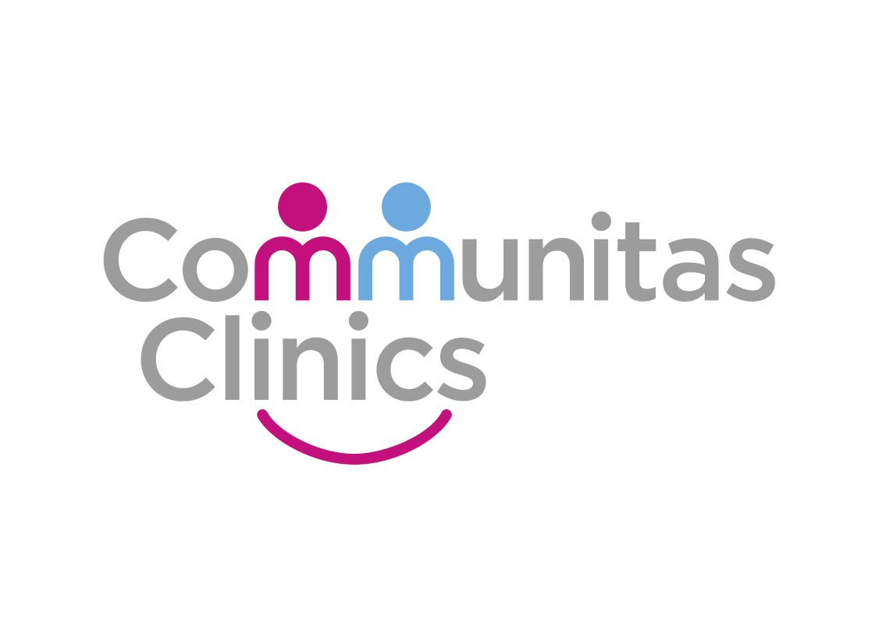

IT_SOP_30

Procedure Name: CROYDON - Accessing Results using Sunquest ICE – RADIOLOGY PATHOLOGY MICROBIOLOGY

Version 1.0

Date: 18/10/2022

Document Revision History.

Date | Version | Authors | Comments/Reasons For Change
18/10/2022 | 1.0 | PH | First issue

Contents

Introduction. 4
Scope. 4
Update Policy. 4
Show patients record 4
Click on the arrow next to Pathology & Radiology on left hand panel 5
Click Pathology Requests 5
Click on the 3 bars 5
Select OK 6
Select Mayday Hospital Pathology 6
Results screen appears 7
Click on result 7
Result screen will appear 8
Selecting back 8
Selecting cancel 9

Introduction.
This document provides details of how to access results using Sunquest ICE – RADIOLOGY PATHOLOGY MICROBIOLOGY from Croydon Hospital.

Scope.
This document defines how Communitas Clinics staff or clinicians can order acess reports from Croydon Hospital, using the Sunquest Ice system linked within SystmOne

Update Policy.
The authorised document editors will review this policy annually and submit revisions to the Document owner for approval.
The authorised document editors will maintain and monitor, as required, data regarding the suitability of this procedure and amend, as necessary.

Show patients record

To view radiology, bloods or swabs you will need to start by being in the patients record.
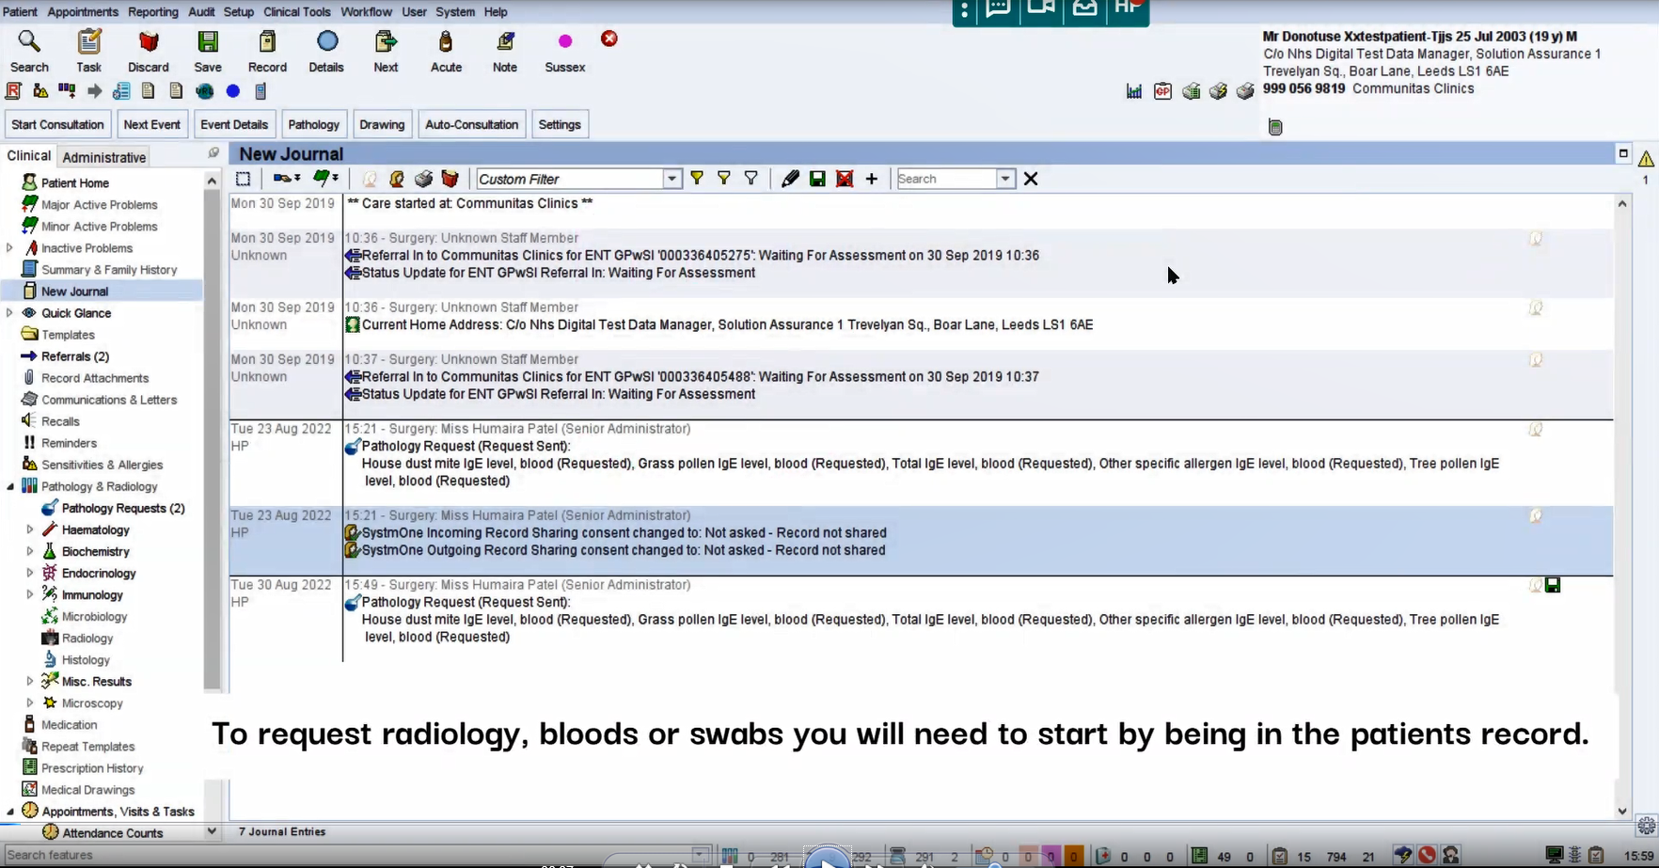

Click on the arrow next to Pathology & Radiology on left hand panel

On the left-hand panel, click on the arrow next to Pathology & Radiology

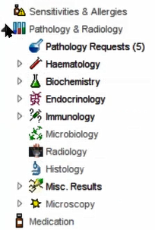

Click Pathology Requests

Select Pathology Requests.

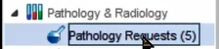

Click on the 3 bars

Select the three blue bars under ‘Pathology Requests’

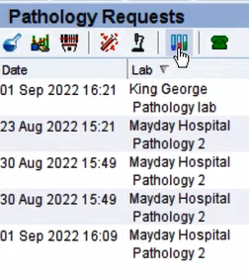

Select OK

Leave as ‘Any’ and select OK

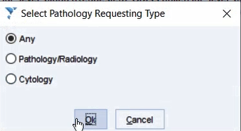

Select Mayday Hospital Pathology

Double-click on Mayday Hospital Pathology 2 Croydon Health Services NHS Trust

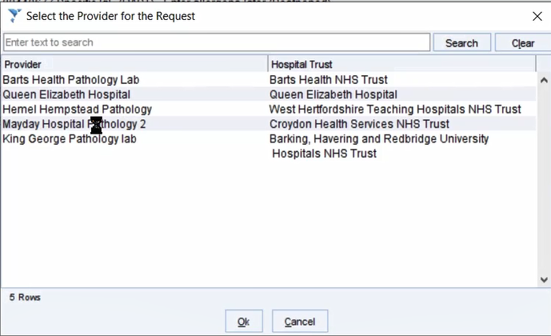

Results screen appears

Sunquest ICE result screen will appear. You should be able to see a list of results. Results from test requested by our service should either have your name or ENT GPSI SERVICE as the requesting clinician and/or it could have RJ6CROYCLINICS listed as the location.

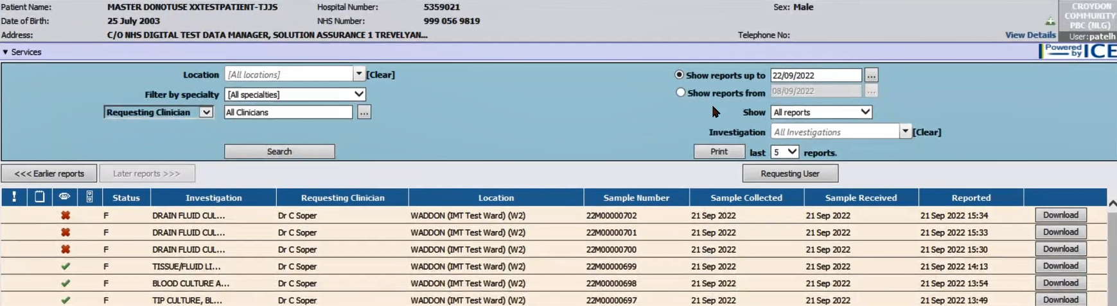

Click on result

Select the result you wish to view.

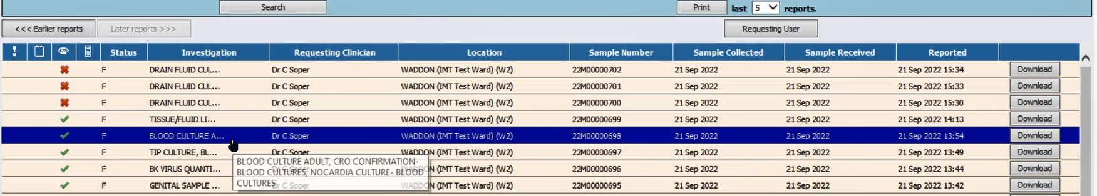

Result screen will appear

You can review the result. You can also print the result by selecting print.

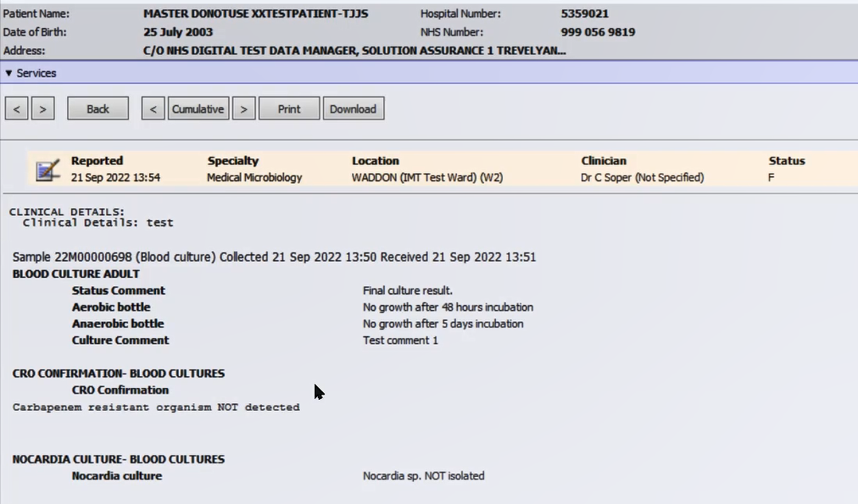

Selecting back

By selecting back, you can go back to the results page

Selecting cancel

Selecting cancel will close the screen and take you back to the patient’s record.

