IT_SOP_33

Procedure Name: BHR - Making requests using CYBERLABS - Immunology Microbiology

Version 1.0

Date: 25/10/2022

Document Revision History.

Date | Version | Authors | Comments/Reasons For Change
25/10/2022 | 1.0 | PH | First issue

Contents

Introduction. 4
Scope. 4
Update Policy. 4
Show patients record 4
Right-click on Pathology & Radiology on left hand panel 5
Select New Electronic Pathology/ Radiology Request 5
Select OK 5
Show new screen 6
Select All 7
Click on specific IgE deselect, select ear swab, deselect 7
Click on blue arrow 7
Show final requesting window 8
Click on the Blue arrow 8
Confirmation Page 9
Print 9
Log out 9

Introduction.
This document provides details of how to make requests using CYBERLABS - Immunology Microbiology for BHR.

Scope.
This document defines how Communitas Clinics staff or clinicians can order Immunology reports from BHRl, using the Cyberlab system linked within SystmOne

Update Policy.
The authorised document editors will review this policy annually and submit revisions to the Document owner for approval.
The authorised document editors will maintain and monitor, as required, data regarding the suitability of this procedure and amend, as necessary.

Show patients record

To request bloods or swabs you will need to start by being in the patients record.

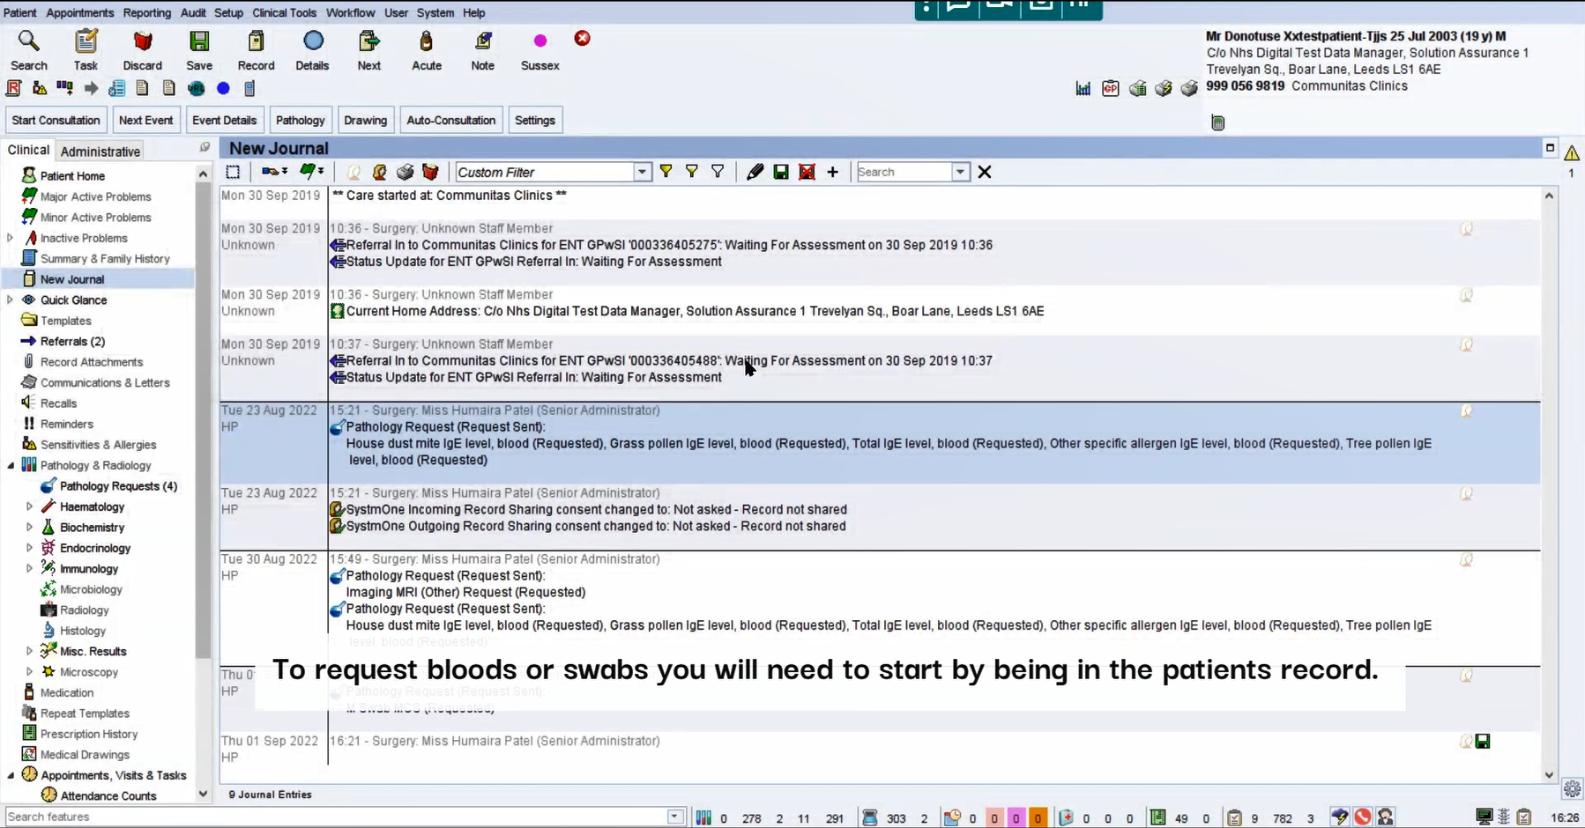

Right-click on Pathology & Radiology on left hand panel

On the left-hand panel, right-click on Pathology & Radiology

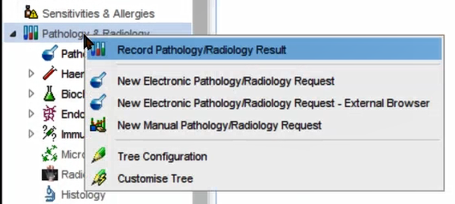

Select New Electronic Pathology/ Radiology Request

Select New Electronic Pathology/ Radiology Request

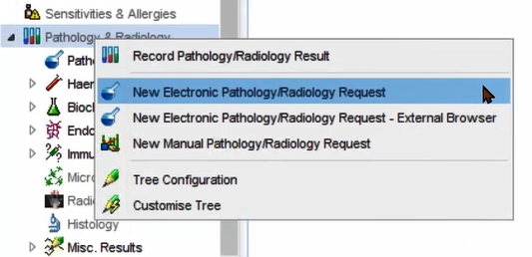

Select OK

Leave as ‘Any’ and select OK

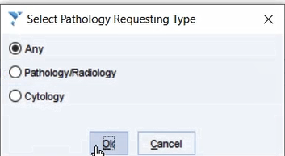

Select King George Pathology lab

Click on King George Pathology lab
Barking, Havering and Redbridge University Hospitals NHS Trust

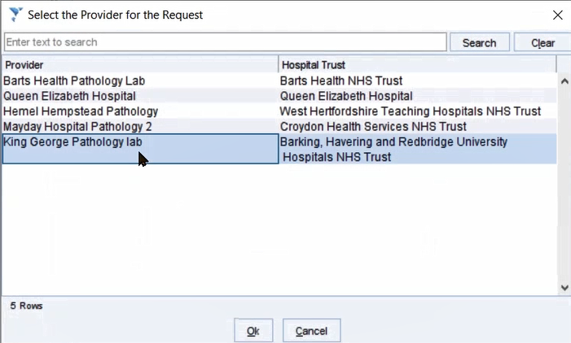

Show new screen

Select the blue arrow on top right to continue

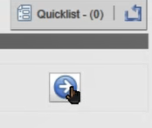

Select All

To bring up all blood requests, select All

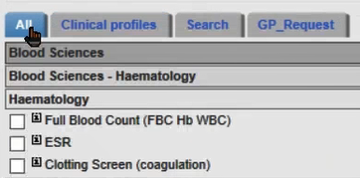

Click on specific IgE deselect, select ear swab, deselect

Select the bloods you would like to request. Or select request for the swab.

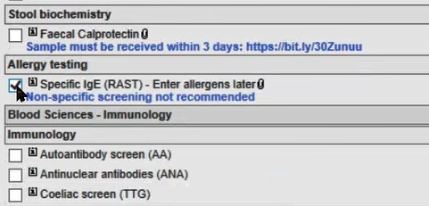

Click on blue arrow

Select the blue arrow on top right to continue

Show final requesting window

Input clinical comment. If you are requesting for specific IgE, state the specific allergens to be tested in the box below.

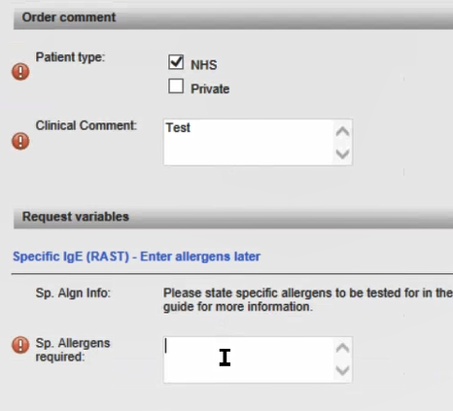

Click on the Blue arrow

Select the blue arrow on top right to continue

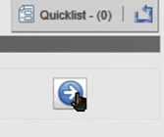

Confirmation Page

Your request has now been sent. A PDF of the form will open automatically. If this does not open, select ‘print summary page in the top right-hand corner.

Print

Select print

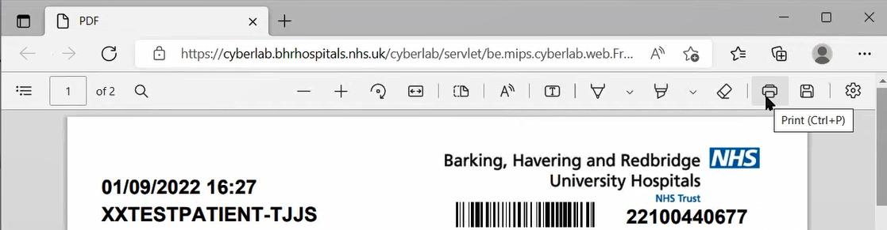

Log out

You must log out of cyberlab using the blue arrow in the top right-hand corner.

