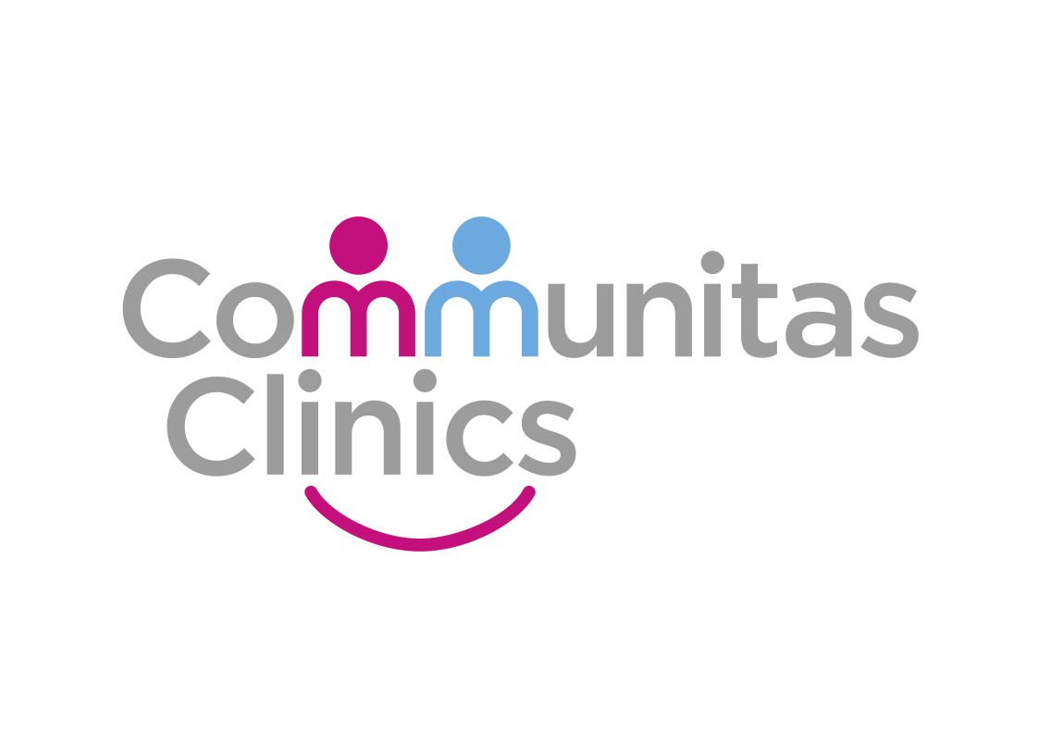

IT_SOP_28

Procedure Name: CROYDON - Making requests using Sunquest ICE - MICROBIOLOGY

Version 1.0

Date: 05/10/2022

Document Revision History.

Date | Version | Authors | Comments/Reasons For Change
05/10/2022 | 1.0 | PH | First issue

Contents

Introduction. 4
Scope. 4
Update Policy. 4
Show patients record 4
Right-click on Pathology & Radiology on left hand panel 5
Select New Electronic Pathology/ Radiology Request 5
Select OK 5
Select Mayday Hospital Pathology 6
Show the new Sunquest Ice screen 6
Select microbiology 7
Click on M Swab MCS 7
Select the body site 8
Select continue with request 8
Show final requesting window 9
Print 10

Introduction.
This document provides details of how to makie requests using Sunquest ICE – MICROBIOLOGY from Croydon Hospital.

Scope.
This document defines how Communitas Clinics staff or clinicians can order Radiology reports from Croydon Hospital, using the Sunquest Ice system linked within SystmOne

Update Policy.
The authorised document editors will review this policy annually and submit revisions to the Document owner for approval.
The authorised document editors will maintain and monitor, as required, data regarding the suitability of this procedure and amend, as necessary.

Show patients record

To request radiology, bloods or swabs you will need to start by being in the patients record.
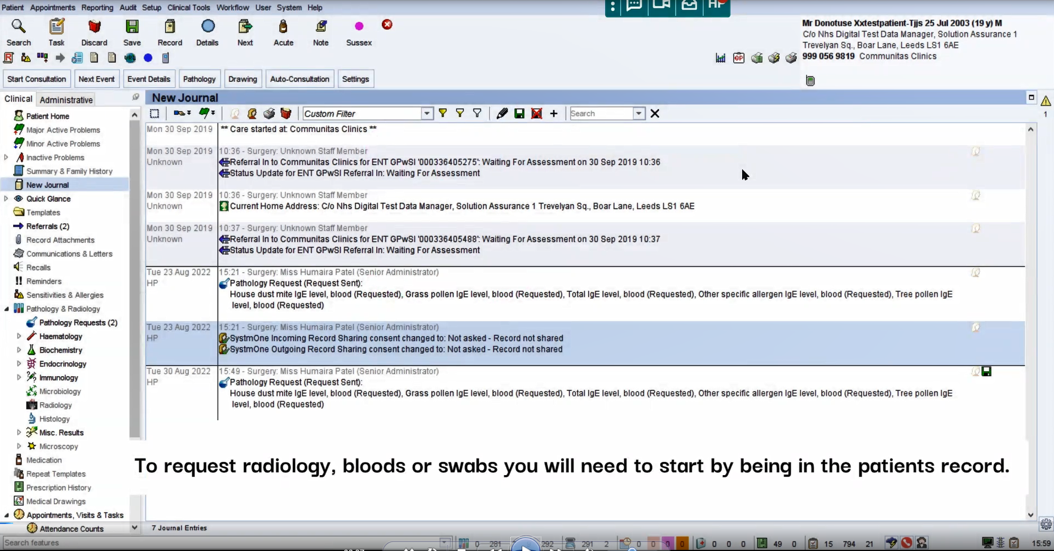

Right-click on Pathology & Radiology on left hand panel

Right-click on Pathology & Radiology on left hand panel
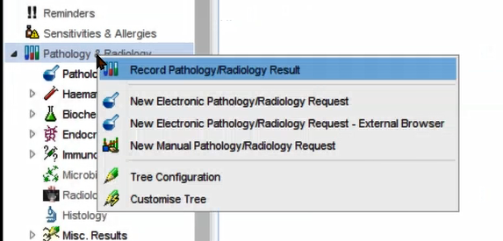

Select New Electronic Pathology/ Radiology Request

Select New Electronic Pathology/ Radiology Request from the menu
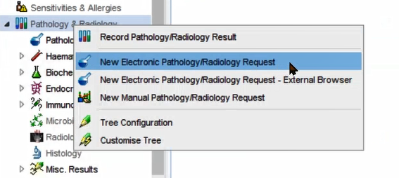

Select OK

Leave as ‘Any’ and select OK
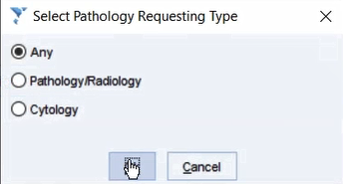

Select Mayday Hospital Pathology

Click on Mayday Hospital Pathology 2 Croydon Health Services NHS Trust

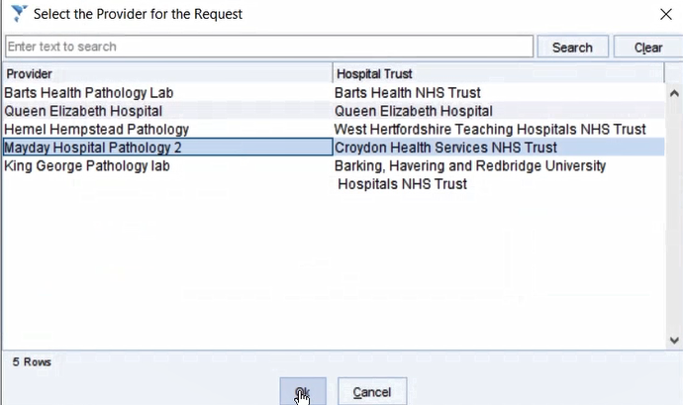

Show the new Sunquest Ice screen

The Sunquest ICE screen will open up. Along the left hand side you will be able to see the different requests that can be made.

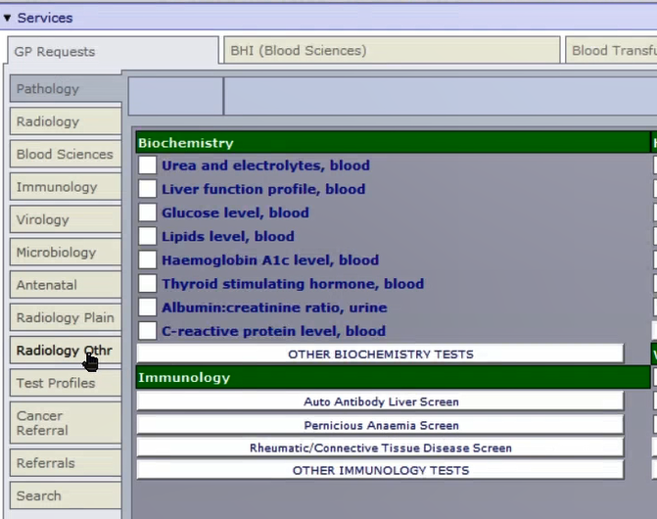

Select microbiology

Click on microbiology on the left-hand panel.

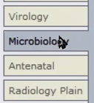

Click on M Swab MCS

Select the relevant request

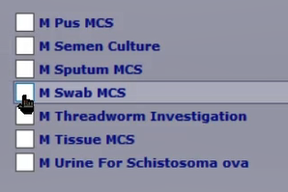

Select the body site

From the drop-down menus, select body site of sample and current antimicrobial therapy. Select OK.

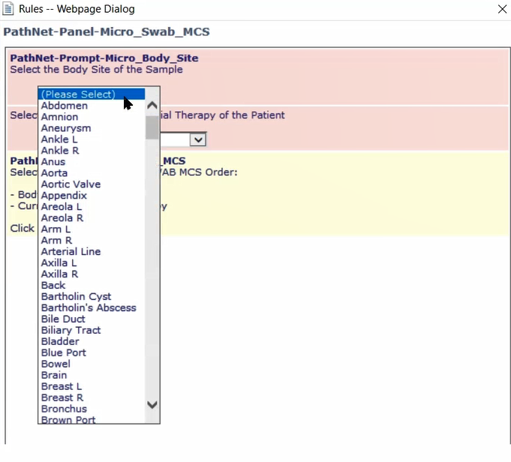

Select continue with request

On the bottom left-hand corner, select the green button “Continue with request…”

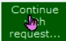

Show final requesting window

Under general details, fill in requesting consultant/ GP and Clinical details.

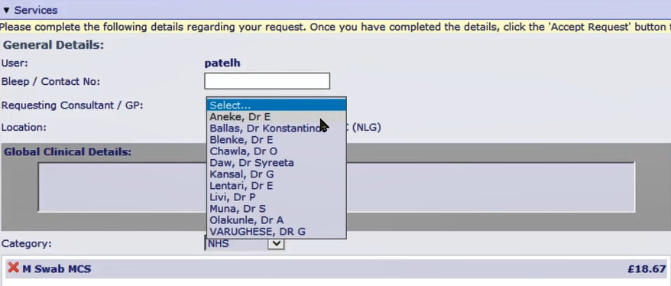

Under order details, ONLY answer the priority and Danger of Infection (high risk) question. Then select accept request.

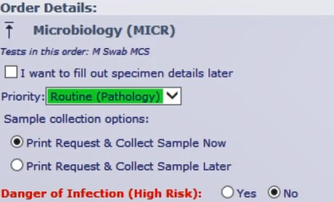

Print

Click on print. Before closing screen ensure the microbiology form is printed.

