IT_SOP_27

Procedure Name: CROYDON - Making requests using Sunquest ICE - RADIOLOGY

Version 1.0

Date: 04/10/2022

Document Revision History.

Date | Version | Authors | Comments/Reasons For Change
04/10/2022 | 1.0 | PH | First issue

Contents

Introduction. 4
Scope. 4
Update Policy. 4
Show patients record 4
Right-click on Pathology & Radiology on left hand panel 5
Select New Electronic Pathology/ Radiology Request 5
Select OK 5
Select Mayday Hospital Pathology 6
Show the new Sunquest Ice screen 6
Click on Radiology other 7
Click on imaging MRI (other) Request 7
Show the validation screen 8
Show the examination screen 8
Show safetynetting screen 9
Back to Sunquest ICE page 9
The final requesting screen 10
Select Accept Request 10

Introduction.
This document provides details of how to makie requests using Sunquest ICE – RADIOLOGY from Croydon Hospital.

Scope.
This document defines how Communitas Clinics staff or clinicians can order Radiology reports from Croydon Hospital, using the Sunquest Ice system linked within SystmOne

Update Policy.
The authorised document editors will review this policy annually and submit revisions to the Document owner for approval.
The authorised document editors will maintain and monitor, as required, data regarding the suitability of this procedure and amend, as necessary.

Show patients record

To request radiology, bloods or swabs you will need to start by being in the patients record.
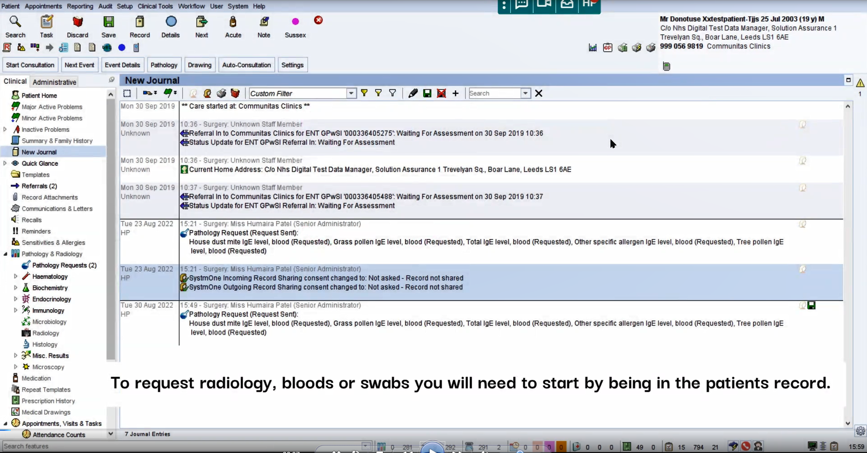

Right-click on Pathology & Radiology on left hand panel

Right-click on Pathology & Radiology on left hand panel
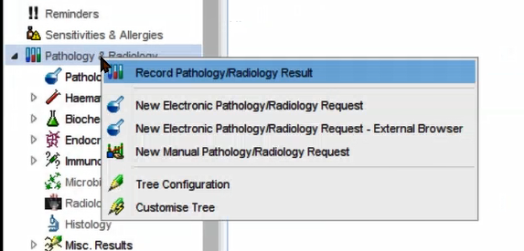

Select New Electronic Pathology/ Radiology Request

Select New Electronic Pathology/ Radiology Request from the menu
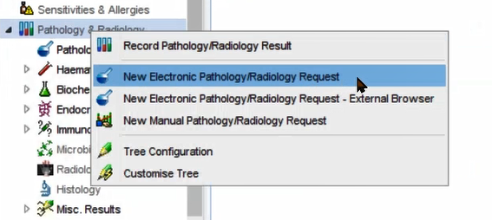

Select OK

Leave as ‘Any’ and select OK
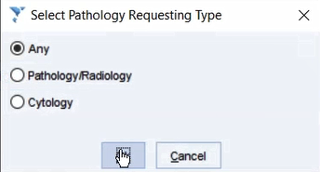

Select Mayday Hospital Pathology

Click on Mayday Hospital Pathology 2 Croydon Health Services NHS Trust

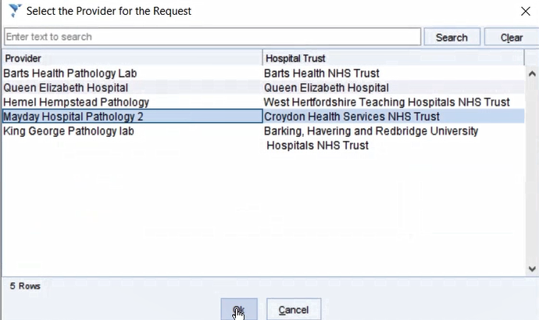

Show the new Sunquest Ice screen

The Sunquest ICE screen will open up. Along the left hand side you will be able to see the different requests that can be made.

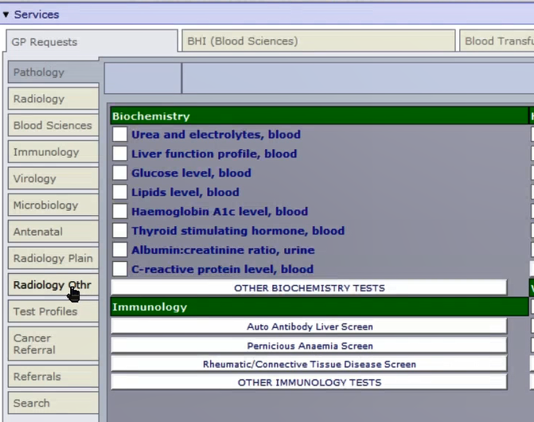

Click on Radiology other

To request radiology, select Radiology Othr on the left hand side.

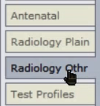

Click on imaging MRI (other) Request

Select the scan you would like to request. If you scan is not listed, then select “imaging MRI (other) Request” or “Imaging CT (other) Request”
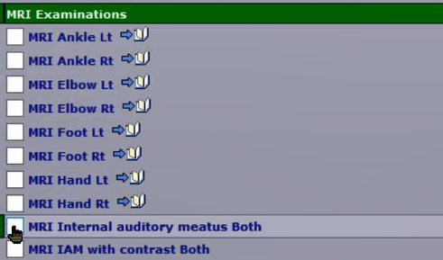

. If you scan is not listed, then select “imaging MRI (other) Request” or “Imaging CT (other) Request”
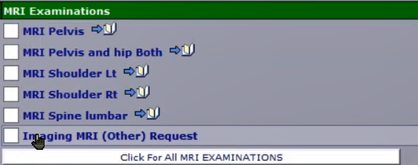

Show the validation screen

You will need to confirm your request is valid and meets the ordering criteria. To do this, select the drop down menu and click on “Request Valid and Meets Ordering Criteria”. Then Select OK

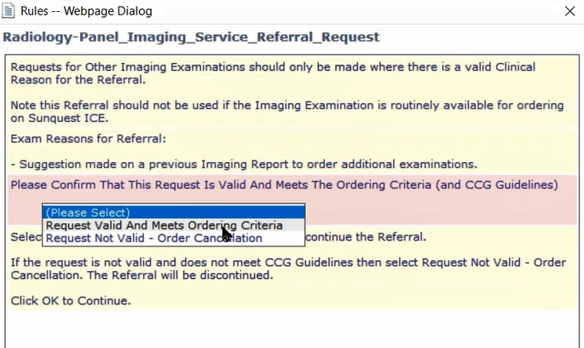

Show the examination screen

Select the examination you would like to request from the dropdown menu, then complete justification reason and clinical details of the patients. Please note, both these sections must be completed.

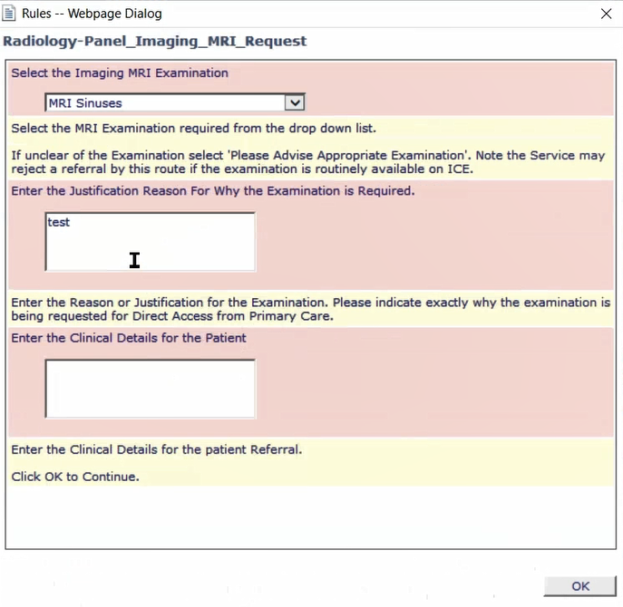

Show safetynetting screen

Go through the safetynetting questions and ensure all are completed correctly. Then select OK.

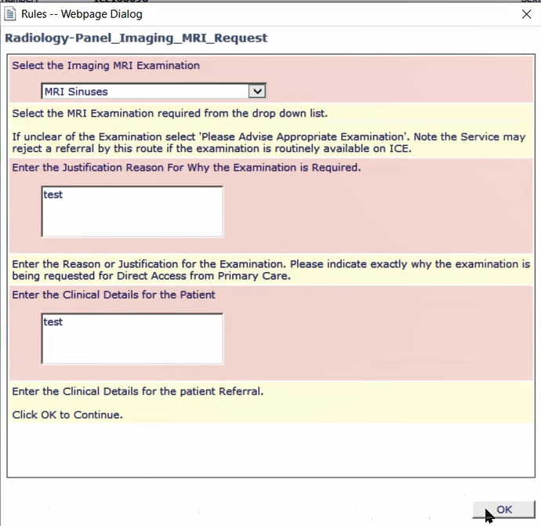

Back to Sunquest ICE page

Select “continue with request…” on the bottom left hand corner.
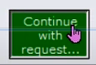

The final requesting screen

Under general details, you will need to select the requestors name.
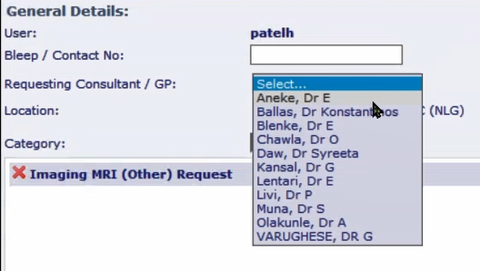

You will also have the option to change the priority of the scan under order details.
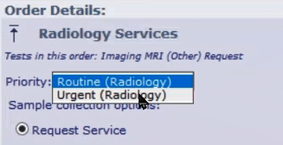

Select Accept Request

To complete you request, select accept request.

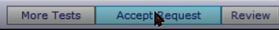

Your request has now been sent to the hospital.
